

**Graduation Project – Term 1**

***Literature Review Report***

**“FAZAA Online System”**

***Submitted by:***

**Name 1: Hamza Ahmed Abushahla ID 1: 662608047**

**Name 2: Eisa Ahmed Alhosani ID 2: 662615156**

**Name 3: Yaaqoub Al Houqani ID 3: 662555671**

**Supervisor: Mr. Nathaniel Haswell Campus: ATHS-AUH-B-MBZ**

**Section: 12-01 [CS] Date: 10-27-2019**

© Applied Technology High Schools, 2016

**Table of contents**

Introduction 2

Sketches and existing products 4

Experts Opinions 5

Conclusion 5

References 6

**Literature Review Report Template**

Your report should include the following:

# Introduction

* **Aims and objectives**

List the objectives of the project and where they are applied.

* + Our project is called **Fazaa Online System**, which is an online platform aiming to automate the mundane tasks related to volunteering in the school, both on the students and the administration side of the matter.
  + The idea of the project came to light to address problems that exist with the currently followed system and attempts to solve them innovatively.
  + Our project addresses the persisting issues of the system that the school currently uses to inform students about upcoming volunteering opportunities, registering students for those events, and keeping an updated record of the students’ progress.
* **Hypothesis**

Decide on a proper design and predict expected results.

* + Our platform draws from and adapts the trend and tradition of hosting events and allowing the public to register for such activities through a digital platform. We currently see many sites that present and provides the public with an insight into the events happening near them and might interest them. Such websites allow users to sign up for those occasions and receive their tickets. Examples include: *platinumlist.net*, *ticketmaster.com* and *800tickets.com*.
  + We predict that by creating this system, more students will be willing to volunteer since it is much easier to register and obtain information, while keeping track of their status.
* **Background Information**
  + Our technology addresses the persisting issues of the system that the school currently uses to inform students about upcoming volunteering opportunities, registering students for those events, and keeping an updated record of the students’ progress.
  + It also addresses the disadvantages that exist with a paper-based system. [1]

Answer all seven questions and paraphrase them in a paragraph.

Our current target audience is students in ACTVET Schools and Institutions, since they are required to have 100 volunteering hours before they graduate, as well as the administration. All students will have to use it before they graduate to sign up for volunteering opportunities and check their progress.

The system will provide useful features to both the administration and the students. On one hand, our project helps the administration to create events for students to volunteer in. In addition to allowing them to reliably and efficiently access and retrieve the school student's progress at any given time from anywhere with an internet connection. And on the other hand, it enables students to get notified when new volunteering opportunities emerge allowing them to sign-up and volunteer. In addition to allowing them to track their progress and volunteering history.

The whole built system is unique in the sense that no paralleling system exists in our school system nor does a pervious attempt exist. However, the idea and style itself indeed exist and it is used and implemented in various forms across the internet. The system replaces the currently followed paper-based and oral system of announcing volunteering opportunities, registering students, collecting hand-written student forms and manual validation, and data entry of each student’s volunteering session.

Future paths for such an idea may include the expansion to and inclusion of other schools in the country which are adopting a similar volunteering aspect in their systems. [2] And ones who face identical trends of the lack of data access and centralization; due to old fashioned paperwork and unorganized data sets.

It might expand to provide digital transformation to SMEs who might require a digitization of their forms and task-tracking procedures [3].

Various existing resource that can be used include the current FAZAA volunteering paper forms, Students volunteering records spreadsheet, Future and past volunteering activities lists, the FAZAA official website and current event sign-up online platforms such as platinumlist.net, ticketmaster.com and 800tickets.com as well as volunteers.ae.

Our project almost has no materialistic cost to build, as it is a software system (web application). Although running it and hosting it on a server may require some fees. The current prototype cost nothing other than time and effort to replicate and maintain.

# Sketches and existing products

Sketches of the designs and machines available in market and show their specifications.

Compile the advantages and disadvantages of each of the items mentioned.

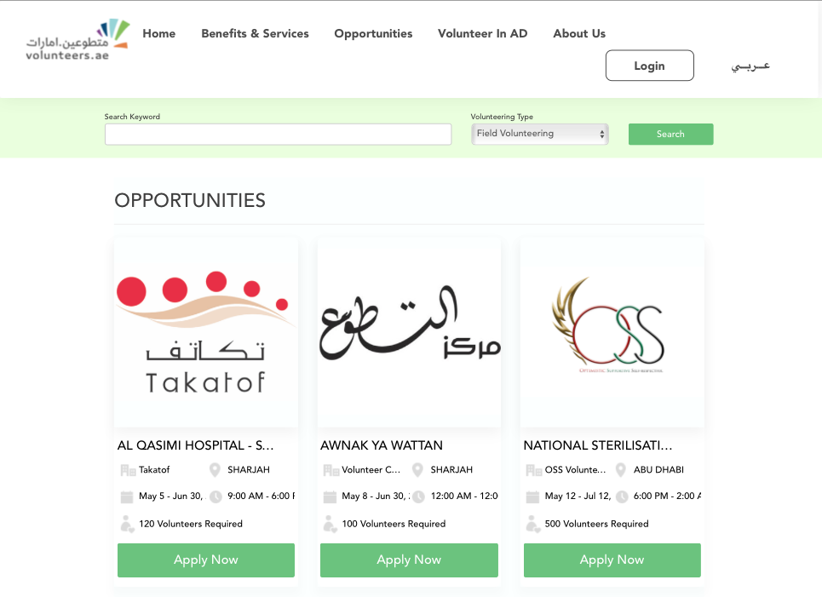

Figure 1- 800tickets website

Figure 2- volunteers.ae website

Figure 3 – Fazaa volunteering paper form

In the currently followed FAZAA system, students are required to fill the paper form (*figure 3*) for each event opportunity they participate in, they are then required to submit this paper form directly to the counsellor’s office, the counsellor will then approve the submitted form manually and will enter the data into a spread sheet on his computer. A followed system which has many disadvantages including the lack of data centralization, the misplace or loss of paper forms and thus the loss of students’ progress, the inability for track their progress without an in-person visit to the counsellor’s office and other disadvantages that accompany following a paper-based system [1]

(*Figure 2*) shows a screen shot of the *volunteers.ae website,* where the volunteering opportunities are presented to the users in a similar way to 800tickets (*figure 1*). The user can click on the “**Apply now**” button to view more information about the opportunity and can click to sign up from there. The user’s information such as his name, ID number, and mobile phone are all linked to his registered user in the database. Thus, there is no need for the user to re-enter his data each time he wishes to volunteer. Which is the advantage of using an online platform, it eliminates the need for the students to fill the paper form with their details on each occasion which is the disadvantage in the existing system.

# Experts Opinions

Our group had a meeting with Mr. Harby and Mr. Wael regarding this project and they told us that this idea was really needed to help them manage efficiently and avoid any hassle. They also told us that they might even consider implementing this idea in their system since it also helps students. As he mentioned *“Student tend to forget that they actually have to do a minimum of 100 hours of FAZAA in order to graduate”.*

The questions that were asked:

* + How many students come by just to check their fazaa’s hour each day?

Mr. Harby’s Response: *“I actually don’t keep count but clearly many students pass by just to check their fazaa’s hour especially senior students.”*

* + We found Fazaa’s online system (<https://eservices.actvet.ac.ae/Fazaa/Account/Login.aspx>) We wanted more elaboration regarding to this website.

Mr. Harby’s Response: *“Me and Mr. Ahmed are actually not sure what’s the website’s purpose since it’s not being used at all.”*

* + We were curious about how does fazaa hours are being recorded, could you explain if you don’t mind.

Mr. Harby’s Response: *“Well, we obviously have a database to keep track of student’s fazaa hours. However, our current method is too hectic, and it needs manual entry therefore we are managing things inefficiently.”*

# Conclusion

* + The idea of the project came to light to address problems that exist with the currently followed system and attempts to solve them innovatively.
  + Our interest was driven by the sense of eagerness and responsibility towards our peers and the school system in general, while also appearing as a situation that can be solved using our knowledge and expertise in the field of computing and information technology.
  + **Fazaa** [2] is the name of the volunteering program at our school system. [3]

# References

|  |  |
| --- | --- |
| [1] | DATASCOPE, “8 Disadvantages of paper document management system,” 2019 November 12. [Online]. Available: https://www.mydatascope.com/blog/en/2019/11/12/8-disadvantages-of-paper-document-management-system/. |
| [2] | Fazaa, “Actvet,” [Online]. Available: https://www.actvet.gov.ae/en/Initiatives/Pages/Fazaa.aspx. |
| [3] | MOE, “UAE School Volunteering Principles,” [Online]. Available: https://www.moe.gov.ae/En/ImportantLinks/Skills/Volunteering/Pages/Principles.aspx. |
| [4] | “Why should SMEs go digital?,” 16 January 2020. [Online]. Available: https://www.straitstimes.com/business/why-should-smes-go-digital. |

Extras :

[Fazaa official website](https://www.actvet.gov.ae/en/Initiatives/Pages/Fazaa.aspx)

[Existing fazaa online system](https://eservices.actvet.ac.ae/Fazaa/Account/Login.aspx)